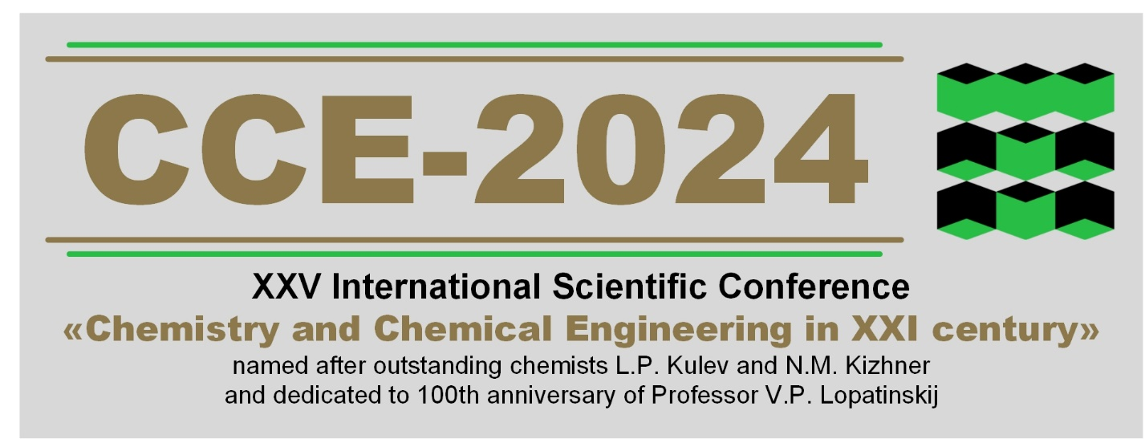
ABSTRACT SUBMISSION GUIDELINE
Potential presenters are requested to submit a two-page abstract in electronic form and application form individually.
Theoretical and empirical abstracts related to Chemistry and Chemical Engineering are considered at the conference.
To provide a uniform appearance, we would appreciate your cooperation in following the next rules:
- You should keep to SI units of measurement and IUPAC terminology;
- Title Times New Roman, 14 pt, 1 line space, centered;
- Authors (initials, surname) Times New Roman, 14 pt, 1 line space, centered;
- Affiliation (academic degree, position, initials and surname of the scientific supervisor and linguistic advisor if necessary) Times New Roman, 14 pt, 1 line space, centered;
- Institute, e-mail Times New Roman, 14 pt, 1 line space, centered;
- Text (introduction, theoretical part, experimental techniques, results and their interpretation) Times New Roman, 14 pt, 1 line space, 3 cm margines A4 paper;
- References (the surname, initials) Times New Roman, 14 pt, 1 line space;
- It should be saved as .DOCX file.
- All the files should be saved under the author last name, as ZIP archive format.
- The archive should be sent via e-mail orgcomHHT@tpu.ru. The subject should be
“CCE-2024” and surname. The e-mail addresses must correspond to the e-mail in the application form.
The contributions that do not satisfy the rules and sent later are NOT considered and published.
All papers will be checked for plagiarism and self-plagiarism. Only papers which originality will be at least 75% are accepted for publication.

Conference “Chemistry and Chemical Engineering in XXI century”, hht.tpu.ru, orgcomHHT@tpu.ru

